**Java if...else Statement**

In programming, we use the if..else statement to run a block of code among more than one alternatives.

For example, assigning grades (A, B, C) based on the percentage obtained by a student.

* if the percentage is above **90**, assign grade **A**
* if the percentage is above **75**, assign grade **B**
* if the percentage is above **65**, assign grade **C**

**1. Java if (if-then) Statement**

The syntax of an **if-then** statement is:

if (condition) {

// statements

}

Here, condition is a boolean expression such as age >= 18.

* if condition evaluates to true, statements are executed
* if condition evaluates to false, statements are skipped

**Working of if Statement**

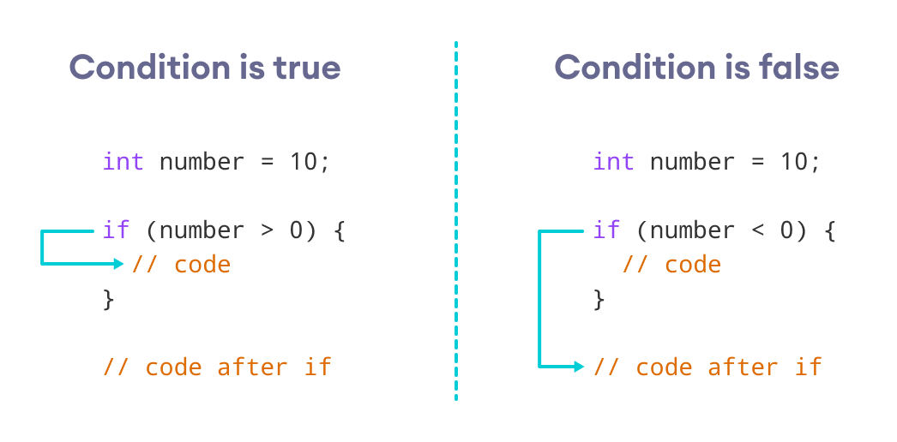Working of Java if statement

**Example 1: Java if Statement**

class IfStatement {

public static void main(String[] args) {

int number = 10;

// checks if number is less than 0

if (number < 0) {

System.out.println("The number is negative.");

}

System.out.println("Statement outside if block");

}

}

[Run Code](https://www.programiz.com/java-programming/online-compiler)

**Output**

Statement outside if block

In the program, number < 0 is false. Hence, the code inside the body of the if statement is **skipped**.

**Note:** If you want to learn more about about test conditions, visit [Java Relational Operators](https://www.programiz.com/java-programming/operators#relational) and [Java Logical Operators](https://www.programiz.com/java-programming/operators#logical).

We can also use [Java Strings](https://www.programiz.com/java-programming/string) as the test condition.

**Example 2: Java if with String**

class Main {

public static void main(String[] args) {

// create a string variable

String language = "Java";

// if statement

if (language == "Java") {

System.out.println("Best Programming Language");

}

}

}

[Run Code](https://www.programiz.com/java-programming/online-compiler)

**Output**

Best Programming Language

In the above example, we are comparing two strings in the if block.

**2. Java if...else (if-then-else) Statement**

The if statement executes a certain section of code if the test expression is evaluated to true. However, if the test expression is evaluated to false, it does nothing.

In this case, we can use an optional else block. Statements inside the body of else block are executed if the test expression is evaluated to false. This is known as the **if-...else** statement in Java.

The syntax of the **if...else** statement is:

if (condition) {

// codes in if block

}

else {

// codes in else block

}

Here, the program will do one task (codes inside if block) if the condition is true and another task (codes inside else block) if the condition is false.

**How the if...else statement works?**

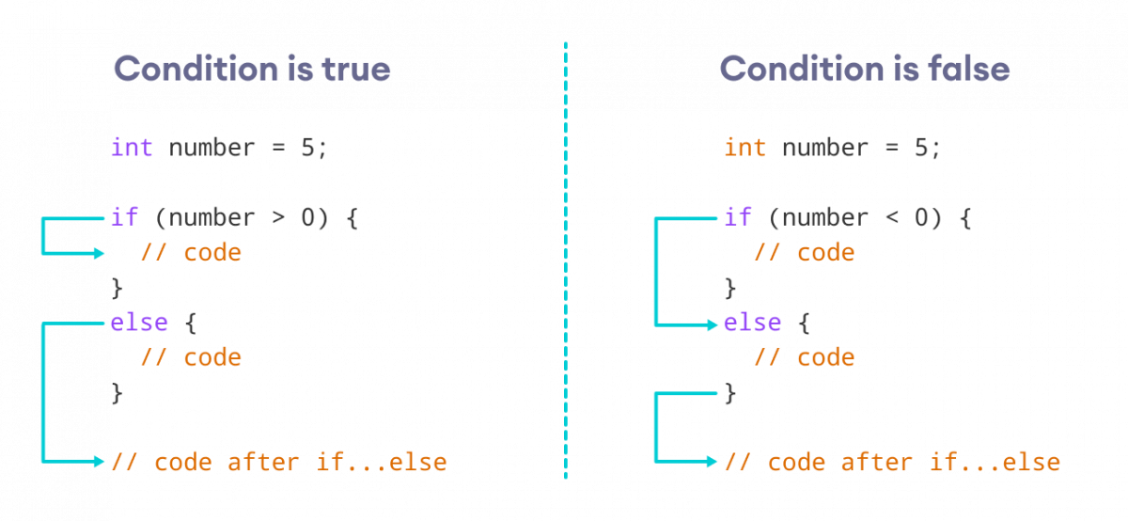Working of Java if-else statements

**Example 3: Java if...else Statement**

class Main {

public static void main(String[] args) {

int number = 10;

// checks if number is greater than 0

if (number > 0) {

System.out.println("The number is positive.");

}

// execute this block

// if number is not greater than 0

else {

System.out.println("The number is not positive.");

}

System.out.println("Statement outside if...else block");

}

}

[Run Code](https://www.programiz.com/java-programming/online-compiler)

**Output**

The number is positive.

Statement outside if...else block

In the above example, we have a variable named number. Here, the test expression number > 0 checks if number is greater than 0.

Since the value of the number is 10, the test expression evaluates to true. Hence code inside the body of if is executed.

Now, change the value of the number to a negative integer. Let's say -5.

int number = -5;

If we run the program with the new value of number, the output will be:

The number is not positive.

Statement outside if...else block

Here, the value of number is -5. So the test expression evaluates to false. Hence code inside the body of else is executed.

**3. Java if...else...if Statement**

In Java, we have an **if...else...if** ladder, that can be used to execute one block of code among multiple other blocks.

if (condition1) {

// codes

}

else if(condition2) {

// codes

}

else if (condition3) {

// codes

}

.

.

else {

// codes

}

Here, if statements are executed from the top towards the bottom. When the test condition is true, codes inside the body of that if block is executed. And, program control jumps outside the **if...else...if** ladder.

If all test expressions are false, codes inside the body of else are executed.

**How the if...else...if ladder works?**

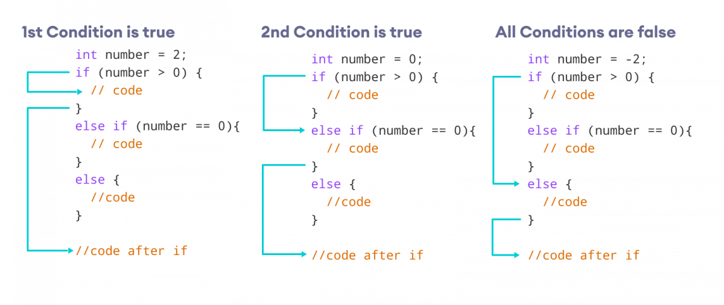Working of if...else...if ladder

**Example 4: Java if...else...if Statement**

class Main {

public static void main(String[] args) {

int number = 0;

// checks if number is greater than 0

if (number > 0) {

System.out.println("The number is positive.");

}

// checks if number is less than 0

else if (number < 0) {

System.out.println("The number is negative.");

}

// if both condition is false

else {

System.out.println("The number is 0.");

}

}

}

[Run Code](https://www.programiz.com/java-programming/online-compiler)

**Output**

The number is 0.

In the above example, we are checking whether number is **positive**, **negative**, or **zero**. Here, we have two condition expressions:

* number > 0 - checks if number is greater than 0
* number < 0 - checks if number is less than 0

Here, the value of number is 0. So both the conditions evaluate to false. Hence the statement inside the body of else is executed.

**Note**: Java provides a special operator called **ternary operator**, which is a kind of shorthand notation of **if...else...if** statement. To learn about the ternary operator, visit [Java Ternary Operator](https://www.programiz.com/java-programming/ternary-operator).

**4. Java Nested if..else Statement**

In Java, it is also possible to use if..else statements inside an if...else statement. It's called the nested if...else statement.

Here's a program to find the largest of **3** numbers using the nested if...else statement.

**Example 5: Nested if...else Statement**

class Main {

public static void main(String[] args) {

// declaring double type variables

Double n1 = -1.0, n2 = 4.5, n3 = -5.3, largest;

// checks if n1 is greater than or equal to n2

if (n1 >= n2) {

// if...else statement inside the if block

// checks if n1 is greater than or equal to n3

if (n1 >= n3) {

largest = n1;

}

else {

largest = n3;

}

} else {

// if..else statement inside else block

// checks if n2 is greater than or equal to n3

if (n2 >= n3) {

largest = n2;

}

else {

largest = n3;

}

}

System.out.println("Largest Number: " + largest);

}

}

[Run Code](https://www.programiz.com/java-programming/online-compiler)

**Output**:

Largest Number: 4.5

In the above programs, we have assigned the value of variables ourselves to make this easier.

However, in real-world applications, these values may come from user input data, log files, form submission, etc.